Online Voting System – MIS Application
Domain:
Election / Voting Management System

Problem Statement:
Traditional voting systems in small organizations, colleges, or clubs are usually conducted manually. Manual voting can lead to several problems such as inaccurate vote counting, duplicate voting, and difficulty in maintaining records. It also lacks transparency and efficiency.
To overcome these problems, an Online Voting System is developed using Python. The system allows registered users to vote securely through a simple interface. It maintains a record of users, candidates, and votes using text files. The system ensures that only authenticated users can vote and prevents multiple votes from the same user.
This MIS application helps manage voting data efficiently and provides real-time results.

Objectives:
The objectives of the Online Voting System are:
- To develop a simple voting management system using Python.
- To maintain voter and candidate data using text files.
- To allow user registration and login authentication.
- To ensure that each user can vote only once.
- To maintain candidate vote counts automatically.
- To display election results clearly.

Dataset:
The system uses three text files as a database.

1. Users Dataset (users.txt)
Stores registered user credentials.
Example:
Salman Khan,katrina69
Vijay,trisha11
Ranbir Kapoor,deepika99
Anjali,rohan6969
Narendra Modi,giorgia00
Karan Johar,ranveer96
Karthik Aryan,pedo16
Sharadha Kapoor,Aditya7
Kajol Devgan,SRK67
Nayantara,STR99
Fields:
- Username
- Password

2. Candidates Dataset (candidates.txt)
Stores candidate names and vote counts.
Example:
Osama Bin Laden,4
Mahatma Gandhi,2
Rehman Dakait,3
Charlie Kirk,1
Fields:
- Candidate Name
- Vote Count

3. Votes Dataset (votes.txt)
Stores voting records.
Example:
Salman Khan,Osama Bin Laden
Vijay,Mahatma Gandhi
Ranbir Kapoor,Rehman Dakait
Anjali,Rehman Dakait
Narendra Modi,Mahatma Gandhi
Karan Johar,Charlie Kirk
Karthik Aryan,Osama Bin Laden
Sharadha Kapoor,Osama Bin Laden
Kajol Devgan,Rehman Dakait
Nayantara,Osama Bin Laden
Fields:
- Username
- Candidate voted for
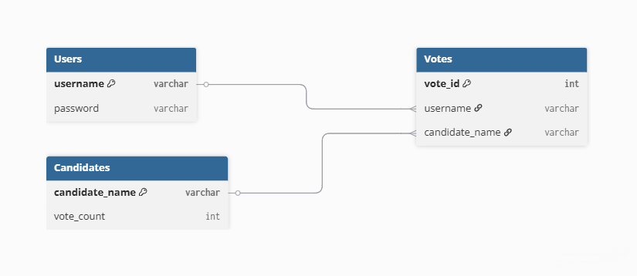
ER Diagram:

Code:
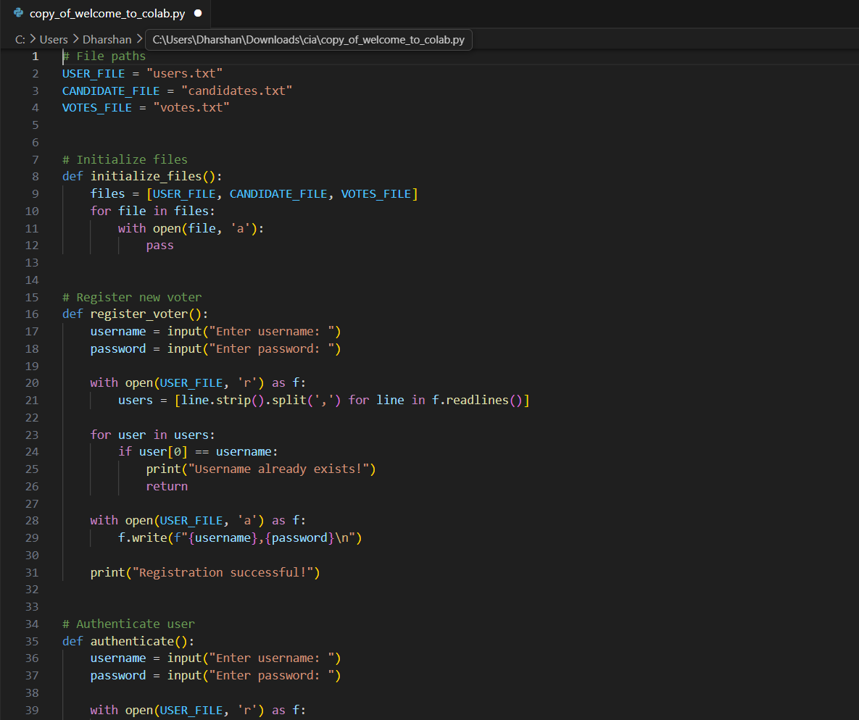

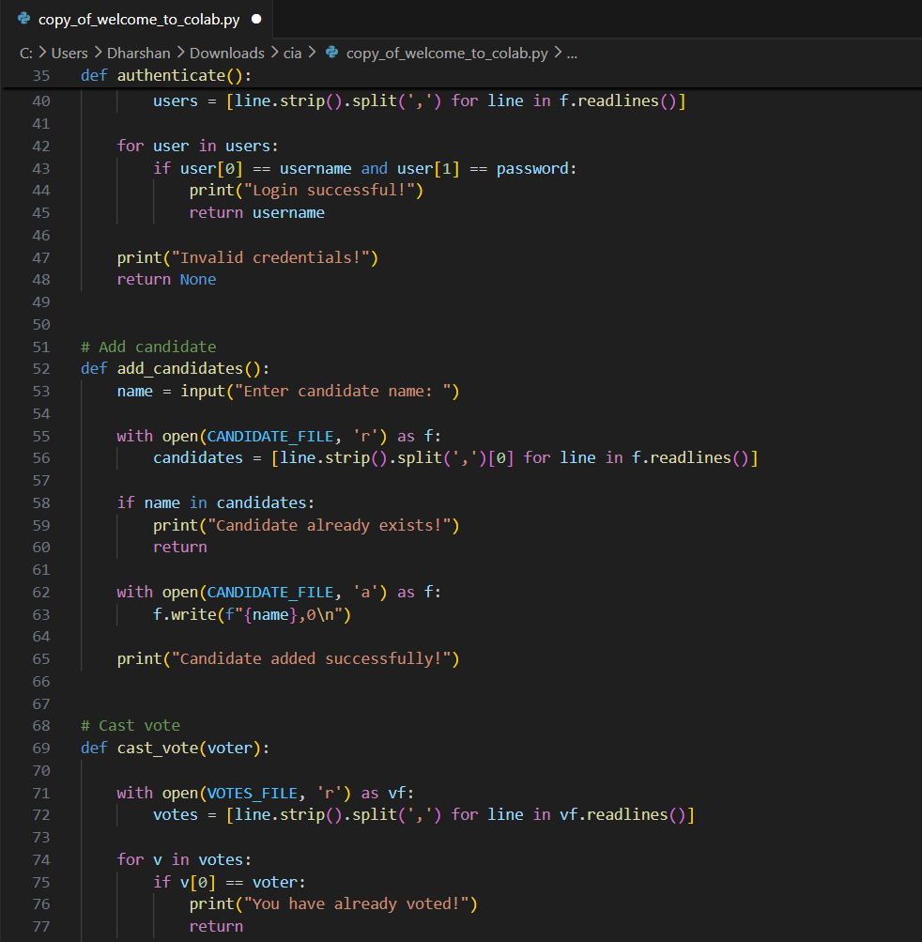

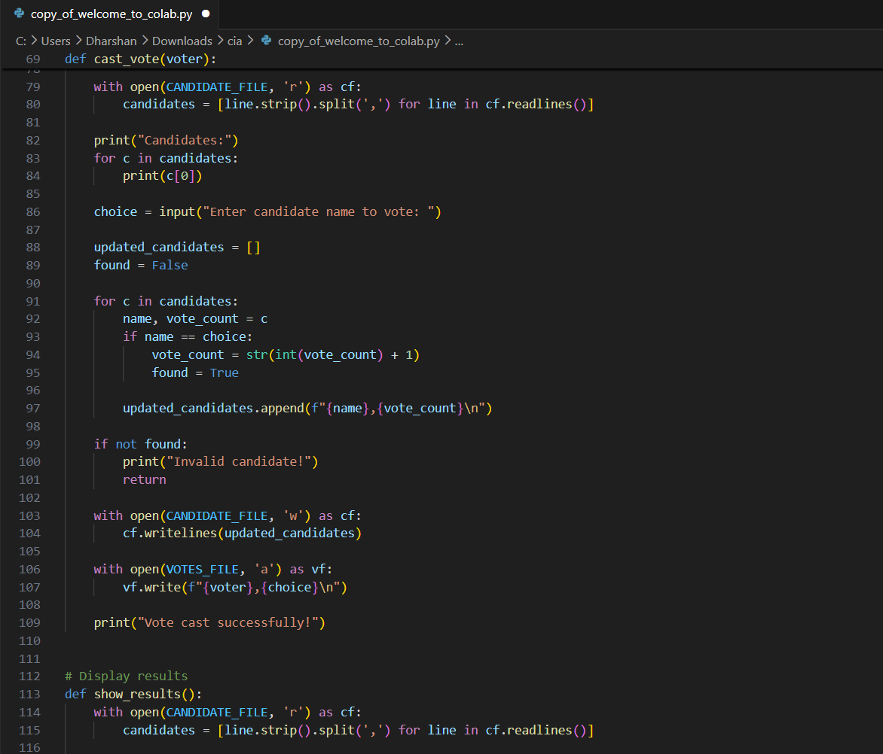

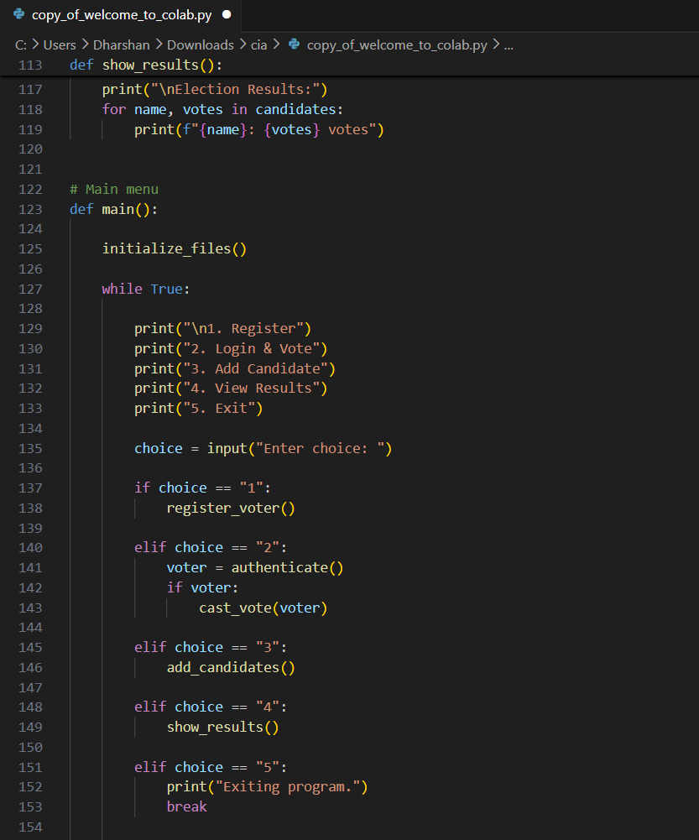
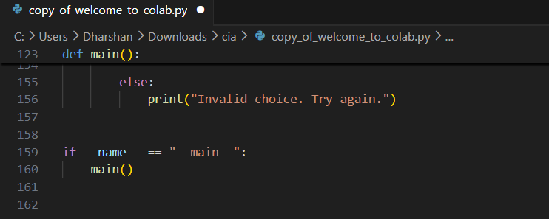

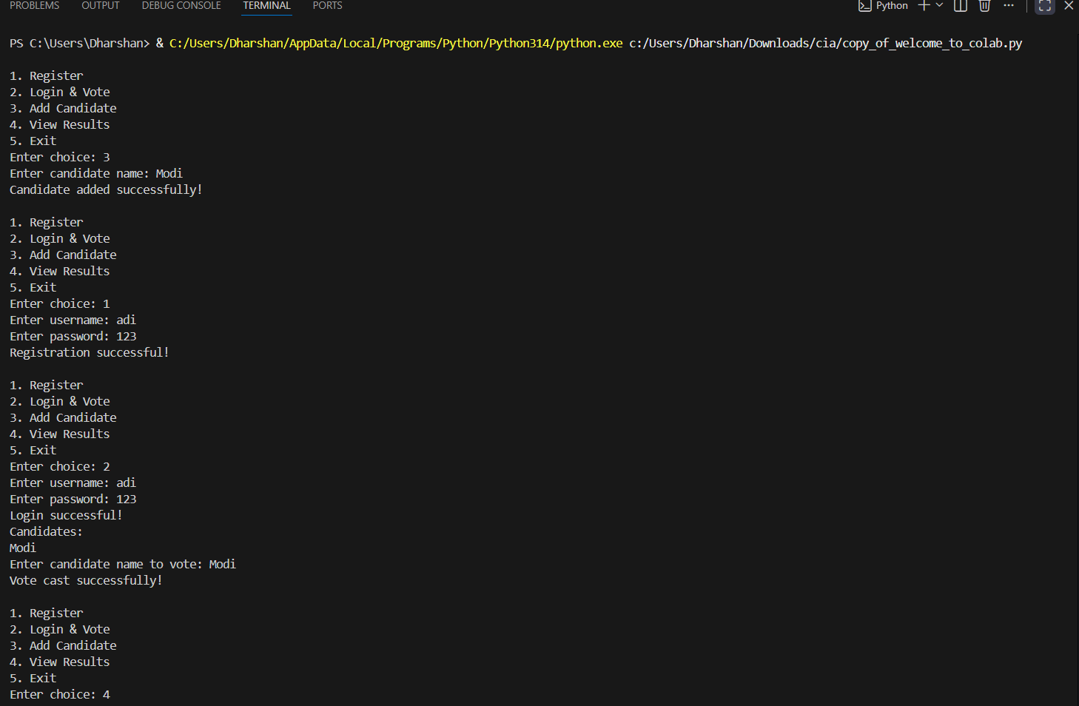
Output:

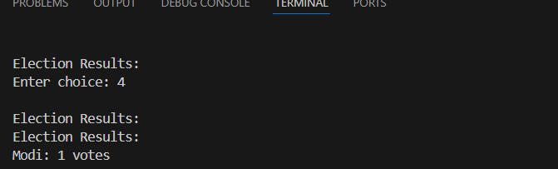
Conclusion:
The Online Voting System developed in this project demonstrates how a simple Management Information System (MIS) can be used to manage and process voting activities efficiently. The system allows users to register, log in securely, and cast their vote for a candidate. It also ensures that each user can vote only once, which helps prevent duplicate voting.
The application uses text files to store user data, candidate information, and voting records. This makes the system simple and easy to implement without requiring complex databases. The system also automatically updates vote counts and displays election results, improving accuracy and transparency.
Overall, the project shows how basic programming concepts such as file handling, user authentication, and data management can be applied to build a practical voting management system.

